JECRC
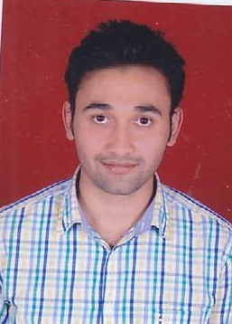
JAIPUR

INDIVIDUAL FACULTY DATA SHEET
Name of the faculty member | : | Prateek Kumar Sharma
Present Designation | : | Assistant Professor
Email Id: prateeksharma.ce@jecrc.ac.in
Contact Details: 7742685582

I. Particulars of Educational Qualification: (only completed)

Category | Name of the Degree | Specialization | Year of Passing | Name of the College | Name of the University
UG | B.Tech | Civil Engineering | 2015 | VIT- East, Jaipur | RTU, Kota
PG | M.Tech | Environmental Engnierring | 2017 | NIFFT, Ranchi | NIFFT, Ranchi
Ph.D. | ----- | ------ | ------ | ------- | -------

II. Academic Experience : 10 Months

III. Industrial Experience : nil

IV. Title of Ph.D. Thesis : N.A.

V. Awards/Achievements : M.Tech Topper, 2015-17 Batch

VI. Research/Specialization : Environmental Engineering

VII. Course Taught : Civil Engineering; Subjects (Environmental Engineering- I, Environmental Engineering and Disaster Management, Basic Civil Engineering)

VIII. Refereed International Journal Publication : 01

IX. International Conference Proceeding : 01

X. Books Written : nil

XI. M.Tech Thesis Guided : nil

XII. PHD Thesis Guided : nil

XIII. Professional Body Membership :nil

